Phase-2
Student Name: P.Charan Babu
Register Number: 732123104020
Institution: Nandha College of Technology
Department: BE. Computer Science And Engineering
Date of Submission: 01/05/2025
Github Repository Link:

Problem Statement
The project aims to build a smart chatbot that can automatically answer their questions, and solve common problems making customer support faster and more efficient.

2. Project Objectives

- Develop an intelligent chatbot that can understand and respond to user queries in natural language.
- Automate common customer support tasks to reduce the need for human agents.

3. Flowchart of the Project Workflow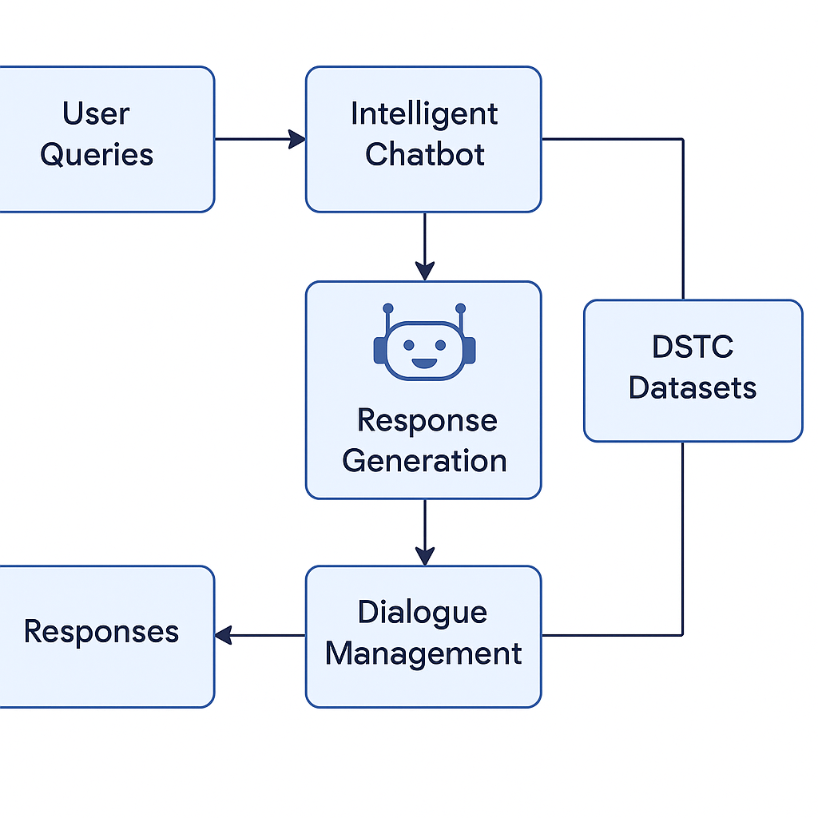

4. Data Description
- Dataset Name: DSTC (Dialog State Tracking Challenge)

- Source: Official DSTC challenge repository

- Type of Data: Text (dialogues, intents, responses)

- Records: Thousands of labeled dialogue sessions

- Features: Speaker, utterance, intent, slots, context

- Nature: Static dataset

- Target Variable: Intent / Dialogue state

5. Data Preprocessing

- Removed incomplete and irrelevant dialogues

- Converted timestamps and structured text

- Encoded categorical data (intent, slots)

- Normalized text (lowercasing, punctuation removal)

- Tokenization using nltk and spaCy

6. Exploratory Data Analysis (EDA)
- Univariate Analysis:
  - Distribution of features Common intents, frequent words

- Bivariate/Multivariate Analysis:
  - Analysis Intent vs. response time

7. Feature Engineering
- Extracted keyword-based features from user utterances
- Created conversation history sequences
- Encoded speaker roles and context window
- Removed highly sparse features

8. Model Building
- Train models
Train-Test Split: 80-20
Evaluation Metrics: Accuracy, F1-Score, Confusion Matrix

- Models used:
RNN (Recurrent Neural Network) with attention
Logistic Regression for baseline intent classification

9. Visualization of Results & Model Insights.
- Evaluation Metrics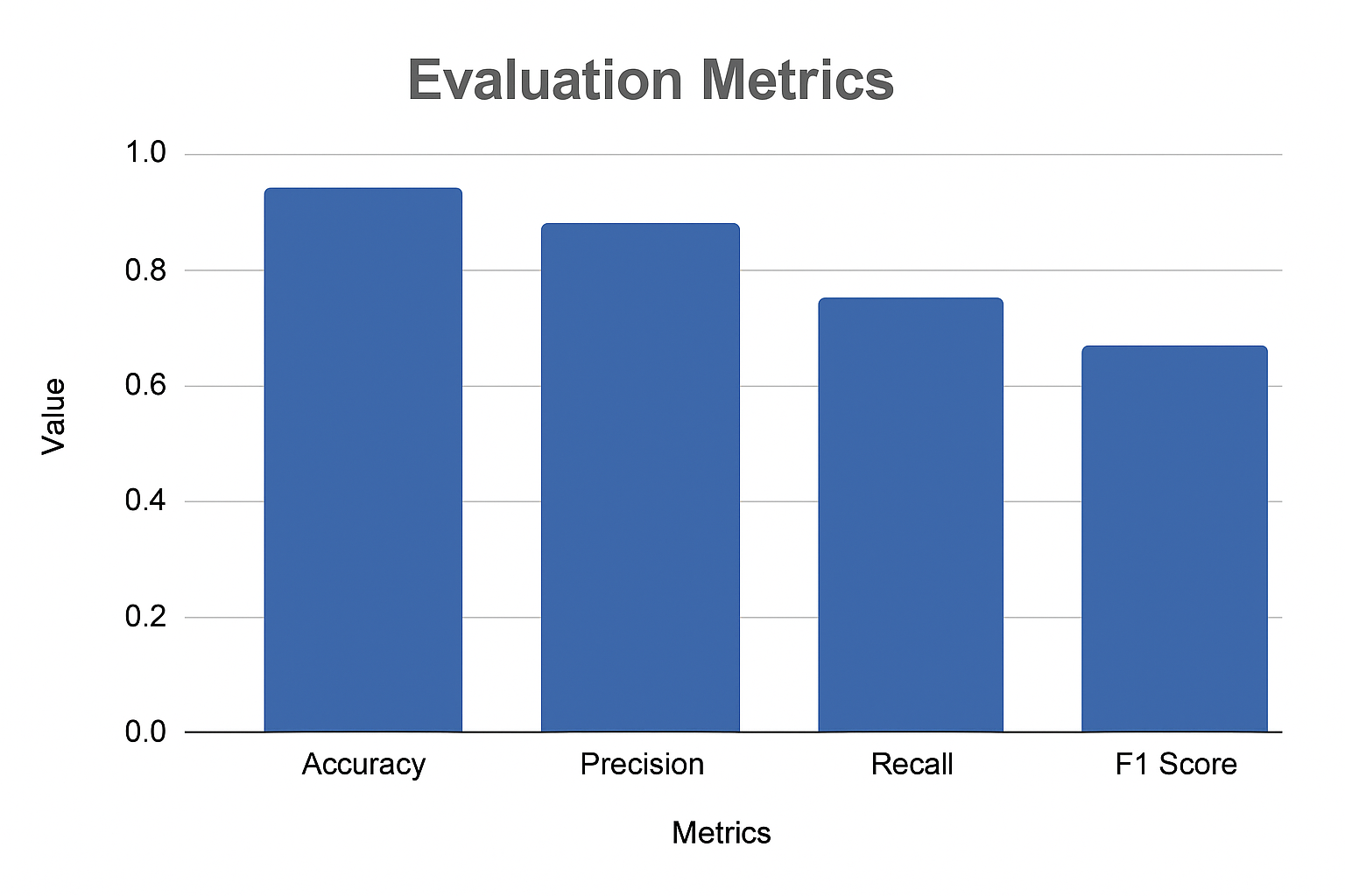

10. Tools and Technologies Used
- Programming Language: Python

- Development Environment –Google Colab

- Libraries: pandas, numpy
- Visualization Tools: Plotly, Tableau, Power BI.]

11. Team Members and Contributions

- S. Harish ragavendra : Experiment with new ideas or models.
- P.Charan babu : Understand and explore the DSTC dataset.
- R.kirutheesh : Focus on interpreting user input.

